**Make earrings with robots**

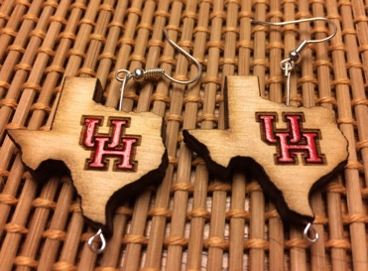

**Make your own custom earrings with lab robots & instruments**

**@ Dr. Becker’s *Robotic Swarm Control Lab***